State Required Crane Inspection

Annual Crane Inspection

An annual inspection of our crane is required by law as indicated below.

Division 1. Department of Industrial Relations
Chapter 4. Division of Industrial Safety
Subchapter 7. General Industry Safety Orders
Group 13. Cranes and Other Hoisting Equipment
Article 99. Testing
§5021. Equipment over Three Tons Rated Capacity.

(a) All cranes and derricks used in lifting service, exceeding three tons rated capacity, and their accessory gear shall not be used until the employer has ascertained that such equipment has been certificated as evidenced by current and valid documents attesting to compliance with the following:

(1) Tests and examinations shall be conducted annually by a currently licensed certificating agency or designee listed in the certificating agency license, and a certificate shall be issued by the certificating agency;

(2) Certificates (annual and quadrennial) attesting to current compliance with testing and examination standards of requirements shall be maintained for each crane or derrick and shall be in a form acceptable to the Division. (See Section 4885, Plate V.)

“Morris Material Handling” is the company we have used to do our testing.

Load Testing with Water Weights

Introduction

In addition to the annual inspection and certification, every four years the 120” dome crane needs a “Proof of Load Test”

Division 1. Department of Industrial Relations
Chapter 4. Division of Industrial Safety
Subchapter 7. General Industry Safety Orders
§5022. Proof Load Test and Examination of Cranes and Their Accessory Gear.
(a) Proof load tests of cranes shall be carried out at the following intervals:

(1) In the case of new cranes, before being taken into initial use and every 4 years thereafter.

(2) In the case of uncertificated cranes which have been in use, at the time of initial certification and every 4 years thereafter.

(3) In the case of major modifications or repairs to important structural components, before they are returned to service.

(4) When certificated equipment is out of service for 6 months or more beyond the due date of a certification inspection, an examination equivalent to an initial certification, including proof load test, shall be performed before the equipment re-enters service.

Water weights are specifically designed to provide a test load using water in place of traditional solid weights for load testing. This certified system allows for a safe and practical method for load testing our crane.
The water bag rental and delivery by truck or truck trailer is handled through the contracted inspection company. “Morris Material Handling” is the company we have used.

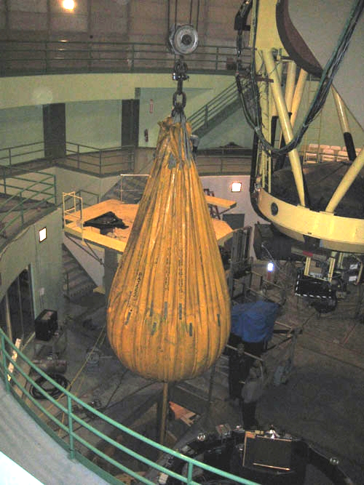

Safety

Be aware of the open floor panel on the dome floor and install chain barriers to prevent people from inadvertently falling through.

Stay clear of the suspended load on the crane hook.

Set-up Procedures

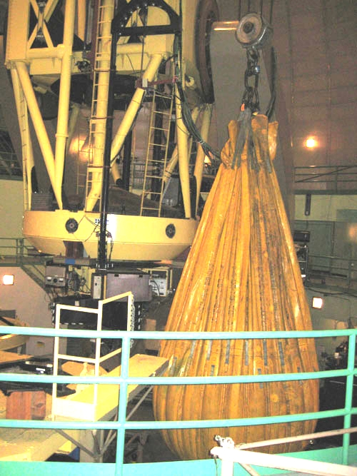
Initial Set-Up Steps. Important: Install the large 15 ton hook. Open the center floor section over the mirror grinder. The inspection company will bring a dynamometer to put between the hook and water weight to measure the total weight of the bag. Connect the bag then lift and center the bag over the floor opening with the drain hose emptying into the reservoir under the mirror grinder. The drain end is located down the hill about 20’ at the end of the light tunnel. Make sure the drain is clear of debris at both ends.

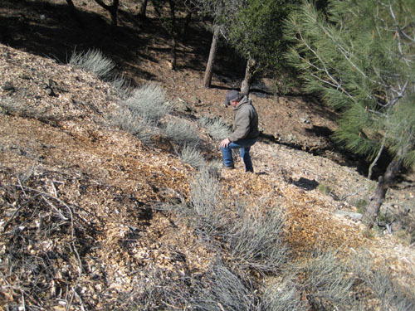
Drain location below light tunnel.

Water Bag Set-Up. Located on the southeast side of the building is the fire hydrant used for filling the water bag.

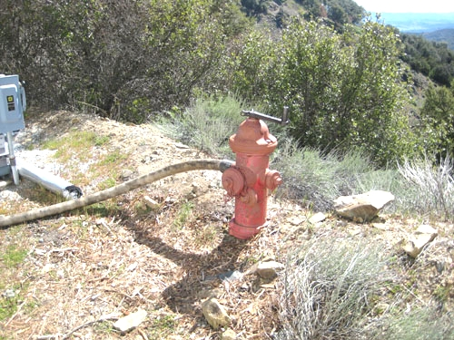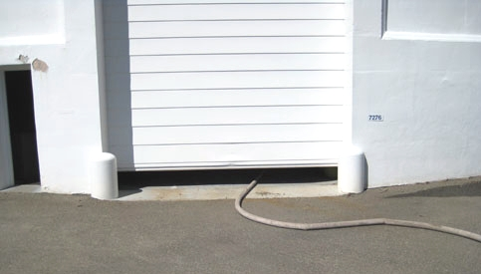

Route the fire hose from the hydrant under the telescopic door, up the stairs through the door next to the coating chamber. Use the pinch valve to regulate the flow of water filling the bag

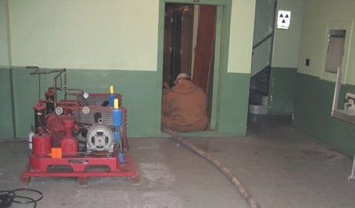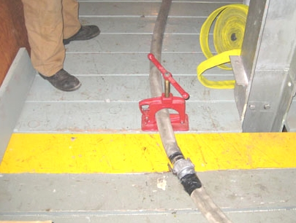

Continue routing the hose up through the open floor panel on the observing floor and thread onto the proper hose on the water bag.
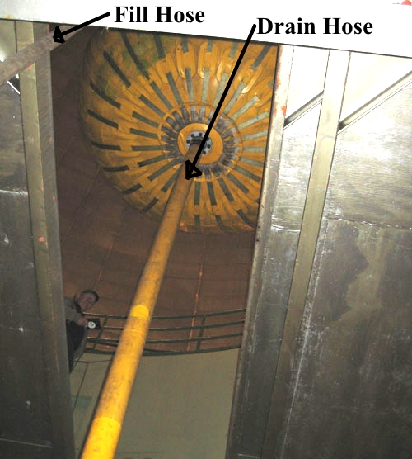
This is the opening in the floor as viewed from the mirror grinder. Note the location of the fill and drain lines. There is a large valve located on the end of the drain line that must be closed for bag filling and when opened at the end of the test it must be restrained with ropes to keep it from flailing about from the discharging water pressure and possibly injuring someone.

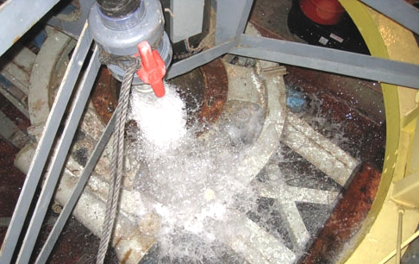

The water will drain slowly from the basin under the grinder so don’t be alarmed to see the basin filled close to the top. Make sure to remove any debris from the basin that might clog the drain before you start draining the bag.

Water Bag removal

The next part of the process is helping the crane contractors to remove the bag from the dome and load it back into their truck.

Start by lowering the bag and stretch it out across the dome floor. The idea is to fold it small enough to fit into the freight elevator, take it to the basement and out the side door where it is wrapped even tighter, placed on a pallet and loaded into the contractors truck.. Below are pictures showing what to do next.

I don’t have pictures getting the bag into the dome but you can pretty-much follow the removal pictures in reverse.
